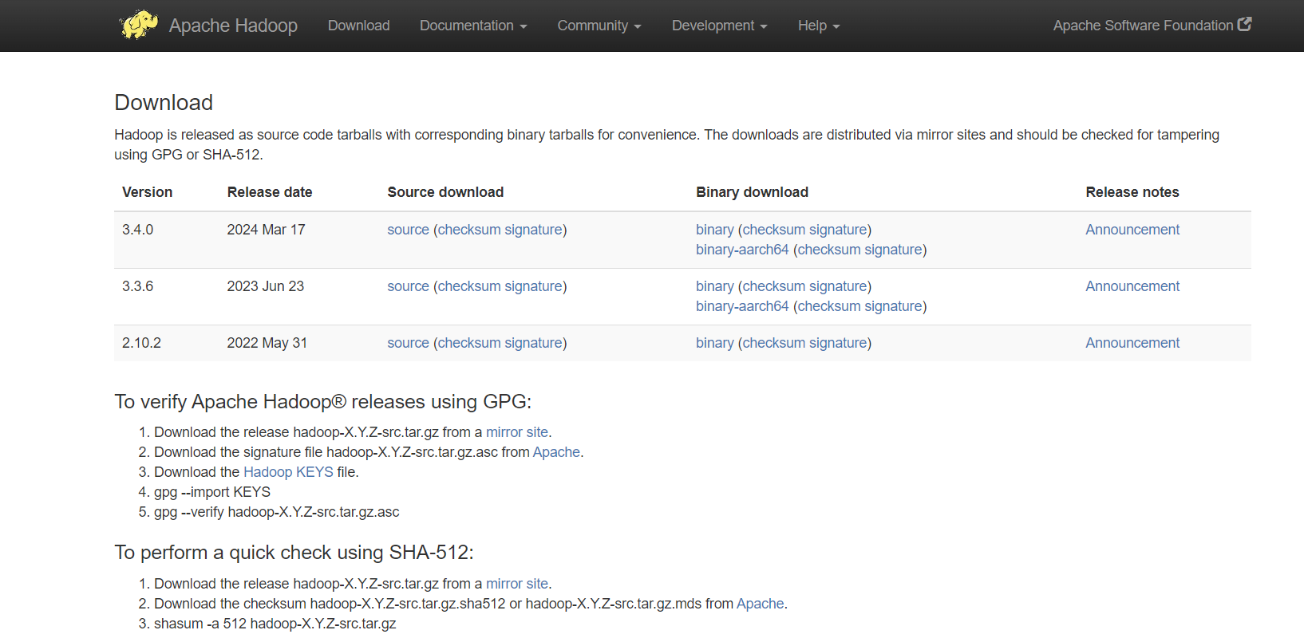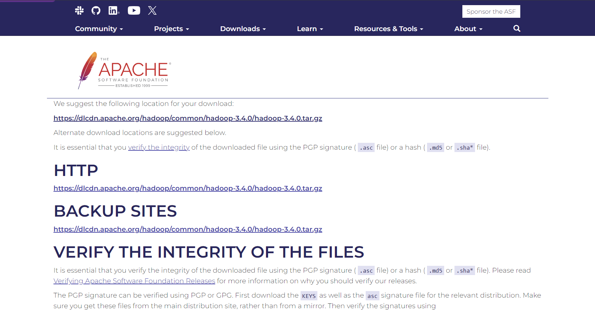  
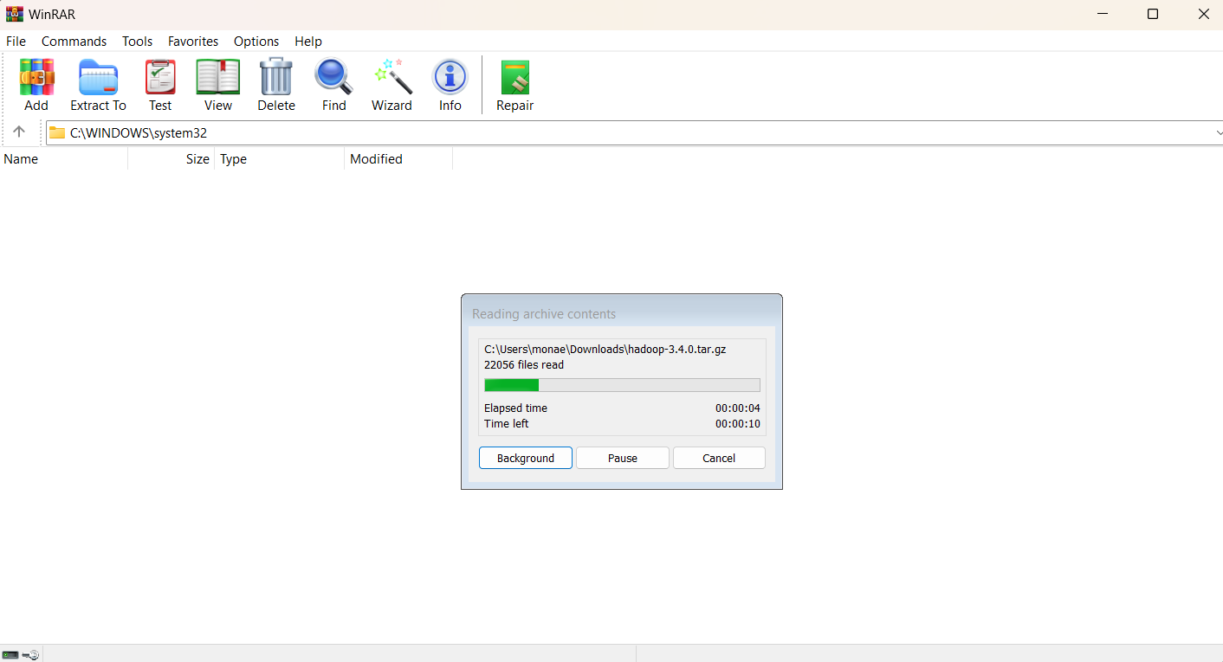

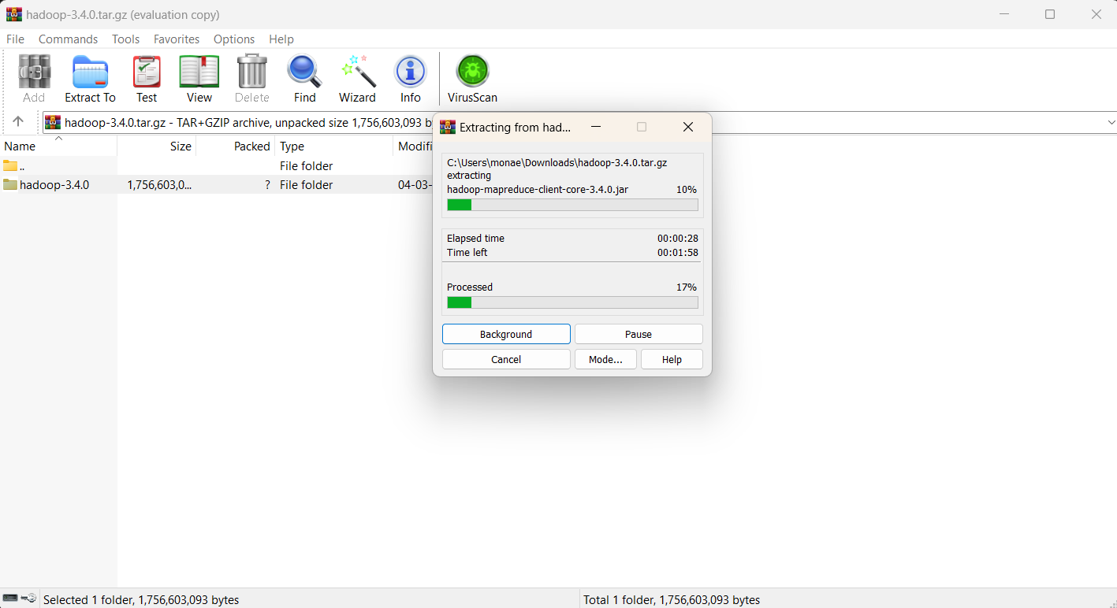  
  
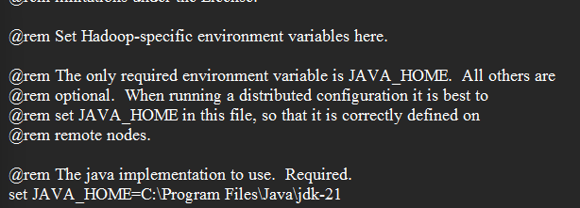  
  
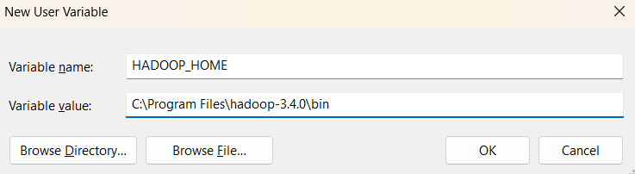  
  
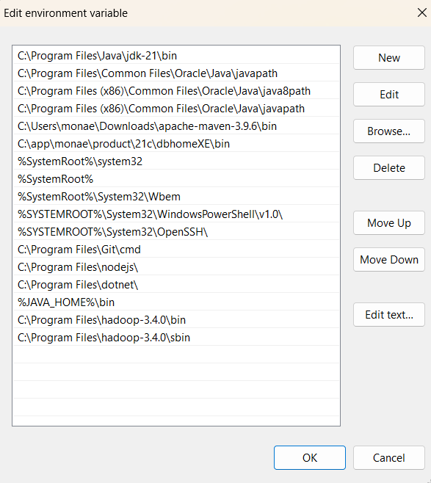

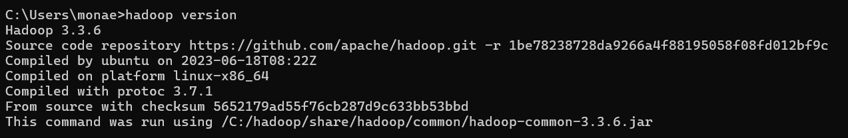  
  
  
  
CORE-SITE.XML  
  
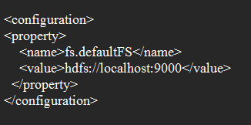

httpfs-site.xml

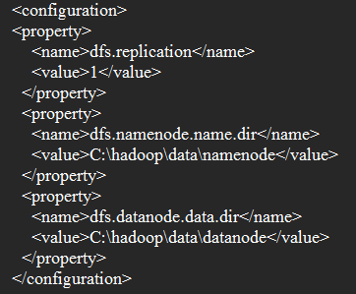

mapred-site.xml

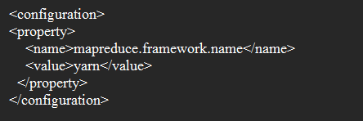  
  
  
  
yarn-site.xml

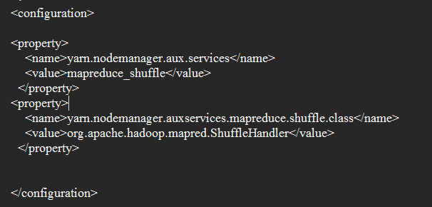

Delete bin and download bin in this link -> https://drive.google.com/file/d/1nCN_jK7EJF2DmPUUxgOggnvJ6k6tksYz/view

msvcr120.dll download (64 bit)  
  
extract -> c drive -> windows -> systems

msvc-170 download (64 bit)

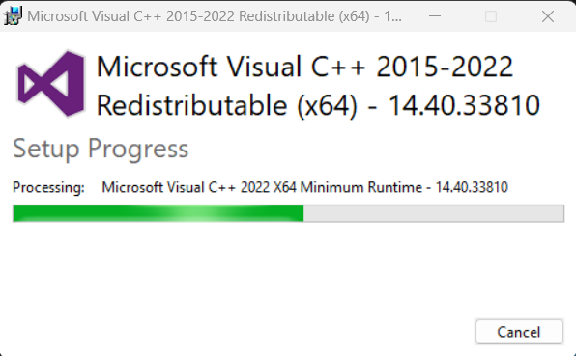  
  
  
RUN AS ADMINISTRATOR  
  
**hdfs namenode -format** -> o/p : shutdown

**cd /**

**cd hadoop  
cd sbin  
start-dfs.cmd  
jps**

**start-yarn.cmd**

**jps**

**Open Browser  
  
localhost:9870 ->   
  
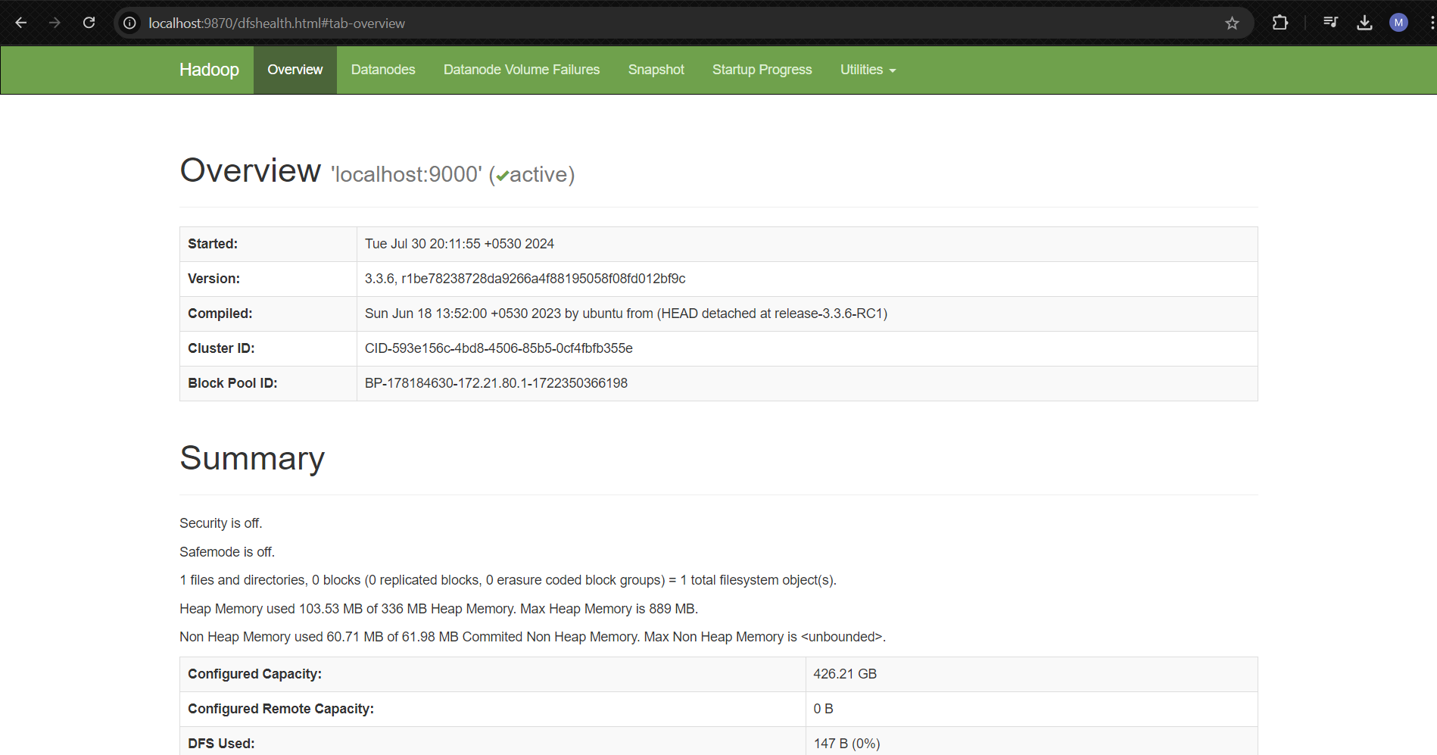  
  
  
localhost:8088  
  
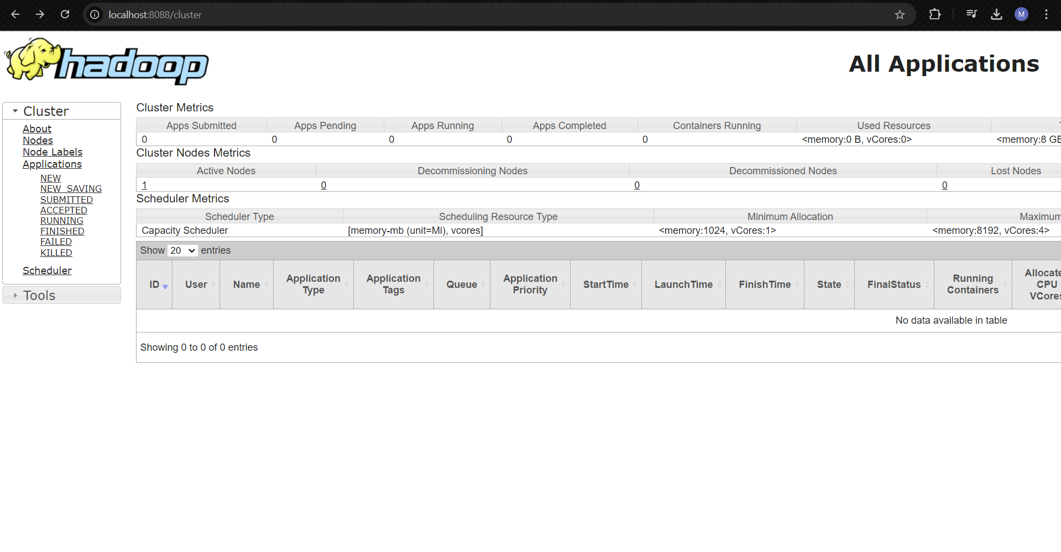**

Stop-all.cmd